**Lourdes Matha College of Science and Technology**

**(Managed By Archdiocese Of Changanacherry)**

**(Affiliated To APJ Abdul Kalam Technological University, Kerala)**

**Kuttichal, Thiruvananthapuram-695574**

**Department of Computer Applications**

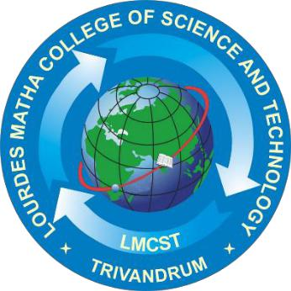

**Certificate**

**This is to certify that the project work entitled “A SECURE IoT BASED MODERN HEALTHCARE SYSTEM USING BODY SENSOR NETWORK” is a bonafide record of the work done by Ms LEKSHMI S R, Reg No LLMC17MCA020, student of Department Computer of Applications, Lourdes Matha College of Science & Technology, Kuttichal, Thiruvananthapuram, affiliated to APJ Abdul Kalam Technological University, Kerala during the academic year 2019-2020 from January 2020 to May 2020 in partial fulfilment of the requirements for the award of the degree of Master of Computer Applications from APJ Abdul Kalam Technological University, Kerala.**

**Internal Guide** **Date:** **Head of the Department**

**Internal Examiner** **External Examiner**